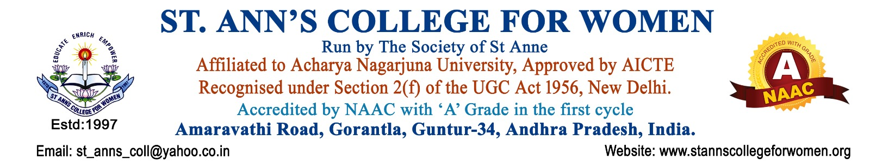

Master of Business Administration (MBA)
Leadership • Management • Entrepreneurship
The MBA programme at St. Ann’s College for Women is designed to develop future business leaders, entrepreneurs, and management professionals through industry-oriented education, practical exposure, and innovative learning.
The programme provides strong foundations in Business Management, Marketing, Finance, Human Resource Management, Entrepreneurship, Operations, Business Analytics, and Digital Business Strategies. Students gain practical knowledge through case studies, internships, industrial visits, seminars, workshops, and live projects.
The MBA curriculum focuses on developing:
- Leadership & Decision-Making Skills
- Strategic & Analytical Thinking
- Communication & Team Management
- Entrepreneurial & Innovation Skills
- Corporate & Professional Ethics
- Digital & Business Technology Skills
Career Opportunities
Graduates can pursue careers as:
- Business Analyst
- Marketing Executive
- HR Manager
- Financial Analyst
- Operations Manager
- Entrepreneur
- Banking & Insurance Professional
- Corporate Consultant
- Project Manager
- Digital Marketing Specialist
Why Choose MBA at St. Ann’s College for Women?
- Experienced Faculty & Mentorship
- Industry-Oriented Curriculum
- Skill Development & Personality Training
- Internship & Placement Support
- Seminars, Workshops & Guest Lectures
- Modern Learning Environment
- Focus on Women Empowerment & Leadership Development
Empowering women with managerial excellence, leadership skills, and entrepreneurial vision for successful careers in the corporate world.
Contact Us
St. Ann’s College for Women
Gorantla, Guntur – 522 034
📞 0863-2236470
📱 73821 04655, 85006 56134
🌐 www.stannscollegeforwomen.ac.in
Admissions Open 2026–27

